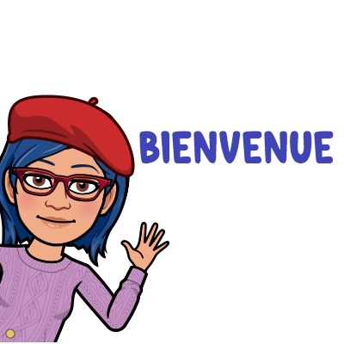
Exploring French 2022-2023
Hidden River MIDDLE SCHOOL
Madame Teefy
E-mail: patricia.teefy@spps.org
OR patricia.teefy@stpaul.k12.mn.us
Phone Number : 651-293-8800, Direct Phone: 651-744-8269

Course Description:
Exploring French is an IB-MYP (International Baccalaureate Middle Years Programme) course, which values communication, holistic learning, and intercultural awareness. Exploring French is designed to be an introduction to French language and Francophone cultures. Students will explore and develop beginning speaking and comprehension skills while building vocabulary and learning about other cultures. This will be learned through the following units of study: identity, self, the classroom environment, likes and dislikes.

Course Objectives:
- To comprehend spoken French.
- To speak in French using good pronunciation.
- To comprehend materials written in French.
- To write and communicate in French.
- To compare and contrast student culture with perspectives found in the French-speaking world.

Class Materials
- Pencils and pens (blue or red for correcting)
- One Notebook only for French
- Fully-charged iPad brought to class daily (bring charger)
- Earbuds or headphones (our textbook will be on the iPad and will have many listening activities in which headphones will be essential!)
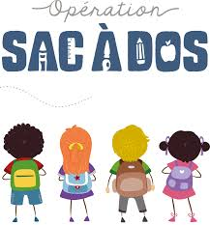
Class Learning Expectations
- We are RESPECTFUL (of oneself, peers, teacher, and surroundings)
- We are RESPONSIBLE (on time, organized, questioning)
- We are READY (prepared, focused)
- Keep cell phones AWAY during class
- If / when you are absent, check SCHOOLOGY – this is where your work will be

Grades
• 40% - Formative Assessments/Activities
• 60% - Summative Assessments/Projects
Formative assessments and activities are everyday assignments and activities that are used to inform how students are progressing within the unit of study. Homework will be included in the formative assessment category.
Summative assessments and projects are typically given at the end of each unit or major section within a unit. There will be many types of assessments and projects, not all will be tests.
MYP Levels of Achievement: Ramsey is an IB-MYP (International Baccalaureate Middle Years Programme) school. All the summative assessments will be given a level of achievement. These levels are: 1-2 limited, 3-4 adequate, 5-6 substantial, or 7-8 excellent. These levels will be reflected in Schoology and are meant to show improvement throughout the year.
Check your grades regularly on Schoology.

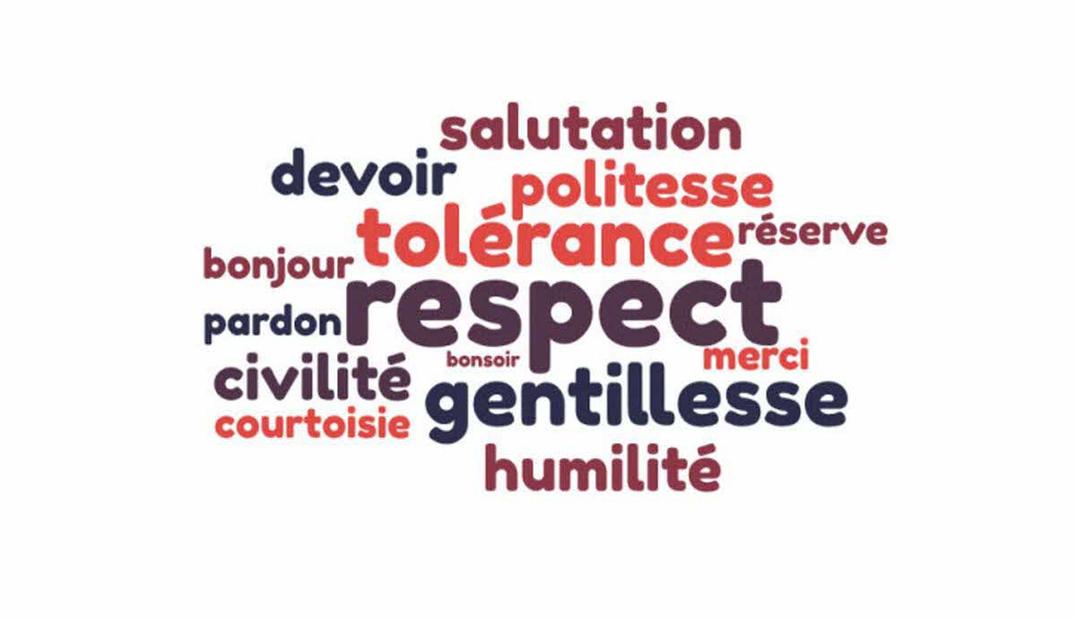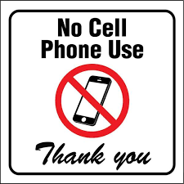

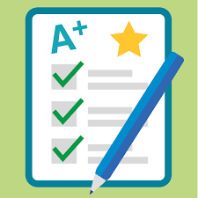

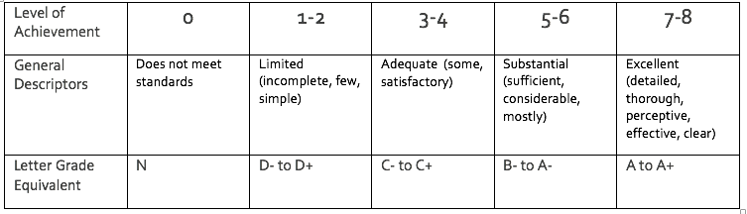

Exploring French, Hidden River Middle School
Allons-y! Amusons-nous! Parlons français!

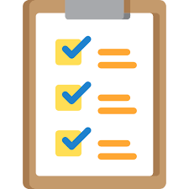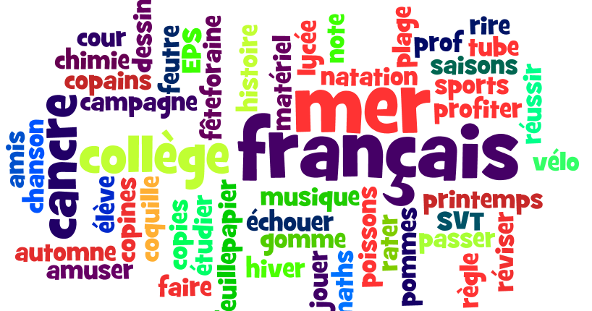
TO DO:
- READ THE SYLLABUS
- HAVE YOUR PARENTS/GUARDIANS READ THE SYLLABUS
- BOTH YOU and YOUR PARENTS/GUARDIANS SIGN AND RETURN or UPLOAD SIGNED FORM TO SCHOOLOGY (this page only.

DONATION PLEASE!
Cooking and other activities are an integral part of French class. In order to do more of these enriching activities, I invite you to make a $10.00 donation (or any amount) for the purchase of food and other materials in French class. If possible, please include your $10.00 donation with the signed form below.
__________________________________________________________________________________________________

Allons-y! Amusons-nous! Parlons français!
5 points

I have read, understand, and will abide by the expectations and rules for French class.

________________________________ ________________________________
Student Name (print) Student Name (signature)

We have read, understand, and will support our student in abiding by the expectations and rules for French class.

________________________________ ________________________________
Parent Name (print) Parent Name (signature)

Parent email address: __________________________________________________________

Date: ________________________________________

